Spro> sales and Distribution > Basic Function>
- Partner Determination
- Customer Master
- Pricing

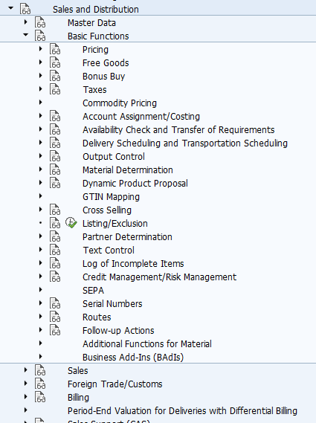

Spro> sales and Distribution > Basic Function>Partner Determination

1 | To Make Partner Functions | VOPAN
https://wiki.scn.sap.com/wiki/display/ERPLO/Partner+determination+procedure+in+SD
https://www.tutorialspoint.com/sap_sd/sap_sd_create_partner_function.htm
Sales and Distribution - Master Data – Business Partners

1 | To make Customer | VD01 | SAP Menu - > Logistics -> Sales and distribution -> Master Data -> Business Partner -> Customer -> Create - > Sales and Distribution and Complete

Spro> sales and Distribution > Basic Function>Pricing
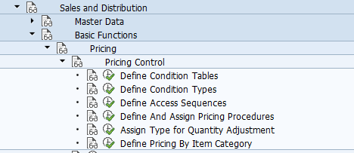

1 | Define condition Tables  - V/03 , V/04, V/05- Create /Change/Display Condition Table. | V/03
3 | Define access sequence  (Maintain sequence of condition table to be used) | V/07
2 | Define Condition Type  (Relate this with access sequence) | V/06
4 | Define and Assign Pricing Procedure  (Assign condition types to pricing procedure) | V/08
5 | Assign sales area( sales org + dist. channel + division) to customer pricing procedure  Define Pricing Procedure Determination | OVKK
6 | Pricing Procedure | VOK0
https://answers.sap.com/questions/9268794/difference-between-pricing-procedures.html
- To create condition records in SD, from the SAP Easy Access screen, choose Logistics Sales and Distribution Master Data Conditions Prices Taxes Create/Change . You can also use transaction VK11 to create or VK12 to change.
- To maintain US condition records, select the condition type UTXJ or to maintain Canadian condition records, select CTXJ.

 | Condition Record | VK11

